Brainstorming & Ideation Phase

1. Introduction
The Brainstorming and Ideation Phase focuses on identifying a suitable method to restrict access to ServiceNow records based on specific field values. The main idea is to use a Script-Controlled ACL (Access Control List) to check a record's field value and determine whether the current user should be allowed or denied access.

2. Objectives
- To understand the requirement for field-based record access.
- To identify the field that should control access.
- To design a Script-Controlled ACL approach.
- To allow access only to authorized users.
- To deny unauthorized access to restricted records.
- To improve record-level security in ServiceNow.

3. Activities Performed
- Analyzed the requirement for restricting record access.
- Identified the field value to be used for access control.
- Discussed different ACL approaches.
- Selected Script-Controlled ACL for dynamic access checking.
- Planned the logic to compare the field value with the permitted value.
- Designed the basic data flow of the access-control process.

4. Expected / Produced Output
- A clear understanding of the field-based access requirement.
- Identification of the required field and permitted value.
- A proposed Script-Controlled ACL design.
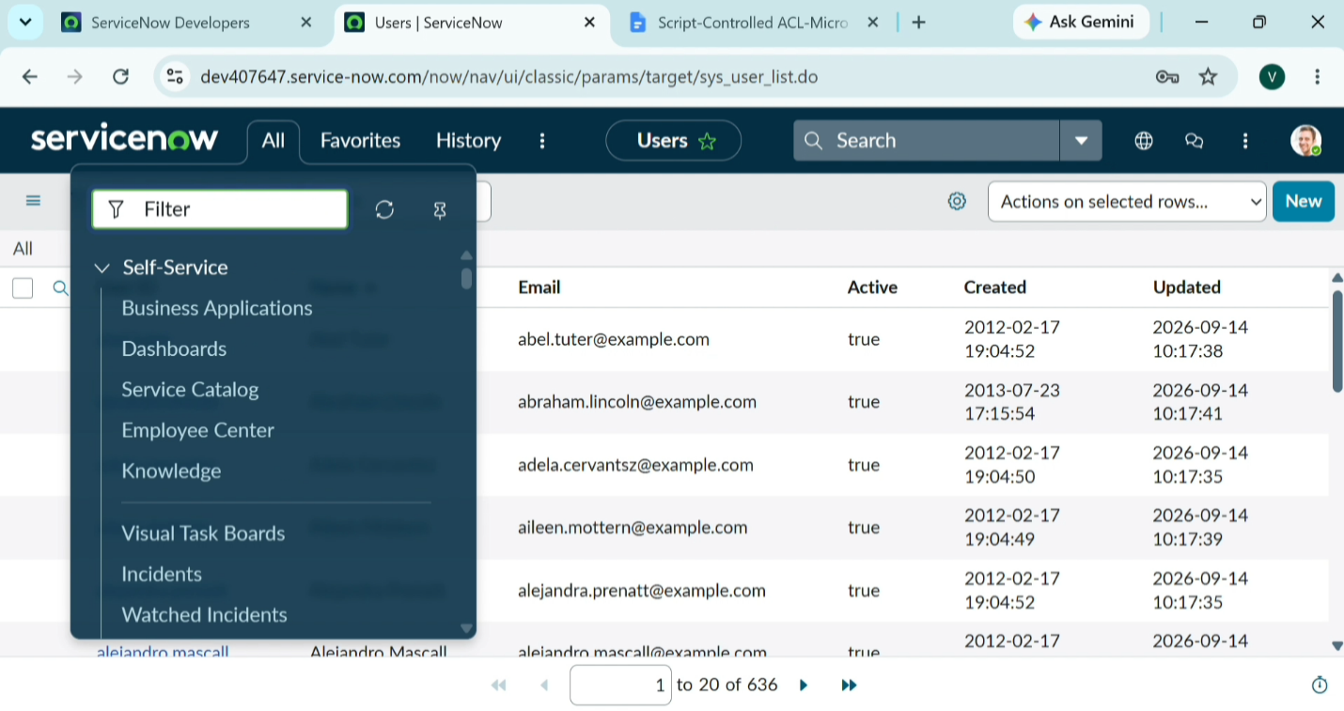

6. Data Flow Diagram

